Name: Krish Singh
Roll: AID25072
B.Tech Artificial Intelligence & Data Science - 2nd Semester
Object Oriented Programming – Lab Assignment 12

Exercises with Experiments

Exercise 1: Component Positioning
Code:
import javax.swing.*;
public class Ex1_Positioning{
public static void main(String[] args){
JFrame frame = new JFrame("Excercise 1");
frame.setLayout(null);
JLabel l1 = new JLabel("Label 1");
JLabel l2 = new JLabel("Label 2");
JLabel l3 = new JLabel("Label 3");
l1.setBounds(50,50,100,30);
l2.setBounds(150,100,100,30);
l3.setBounds(250,150,100,30);
frame.add(l1);
frame.add(l2);
frame.add(l3);
frame.setSize(400,300);
frame.setVisible(true);
}
}
Output:
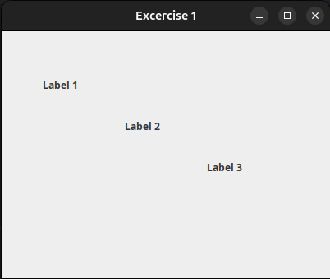

Exercise 2: Visibility and Size

Code:

import javax.swing.*;
public class Ex2_visibility{
public static void main(String[] args){
JFrame frame = new JFrame("Excercise 2");
frame.setLayout(null);
JLabel label = new JLabel("Hello World !");
label.setBounds(50,50,40,20);
frame.add(label);
frame.setSize(400,400);
frame.setVisible(true);
}
}
Output:
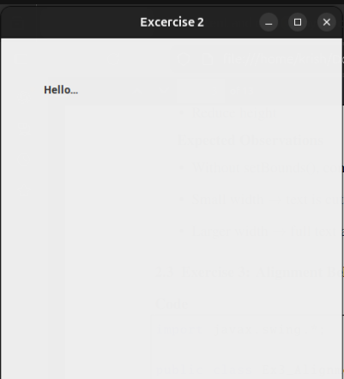

Exercise 3: Alignment Behavior

Code:

import javax.swing.*;
public class Ex3_Alignment{
public static void main(String[] args) {
JFrame frame = new JFrame("Excercise 3");
frame.setLayout(null);
JLabel label = new JLabel("Aligned Text");
label.setBounds(50,50,200,40);
label.setHorizontalAlignment(JLabel.CENTER);
frame.add(label);
frame.setSize(300,200);
frame.setVisible(true);
}
}
Output:

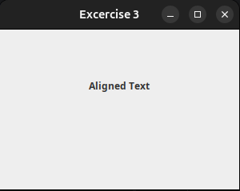

Exercise 4: Color and Background

Code:

import javax.swing.*;
import java.awt.*;
public class Ex4_color{
public static void main(String[] args){
JFrame frame = new JFrame("Excercise 4");
frame.setLayout(null);
JLabel label = new JLabel("Color Demo");
label.setBounds(50,50,150,40);
label.setForeground(Color.RED);
label.setBackground(Color.GREEN);
label.setOpaque(true);
frame.add(label);
frame.setSize(400,400);
frame.setVisible(true);
}
}

Output:
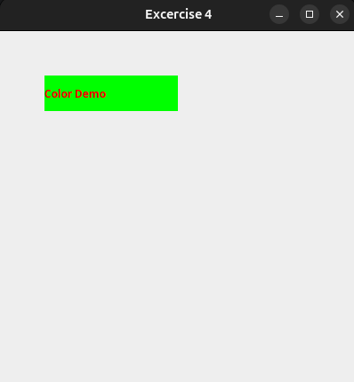

Application Integration – Scenarios

Scenario 1: Student List (Basic)
Code:
import java.util.*;
class Student{
String name;
Student(String name){
this.name=name;
}
String getName(){
return name;
}
}
class StudentSystem{
ArrayList<Student> students = new ArrayList<>();
void addStudent(Student s){
students.add(s);
}
void showStudents(){
for(Student s : students){
System.out.println(s.getName());
}
}
}

Scenario 2: Attendance System (Intermediate)
Code:
import java.util.*;
class Student2{
String name;
boolean present;
Student2(String name){
this.name=name;
present=false;
}
String getName(){
return name;
}
void markPresent(){
present=true;
}
void markaAbsent(){
present=false;
}
boolean isPresent(){
return present;
}
}
class AttendanceSystem{
ArrayList<Student2> students = new ArrayList<>();
void addStudent(Student2 s){
students.add(s);
}
void showStudents(){
for(Student2 t : students){
System.out.println(t.getName());
}
}
void markPresent(Student2 name){
for(Student2 t : students){
if(t.getName().equals(name)){
t.markPresent();
}
}
}
void showPrsentStudents(){
for(Student2 std : students){
if(std.isPresent()){
System.out.println(std.getName());
}
}
}
}

Scenario 3: Quiz Participation Tracker
Code:
import java.util.*;
class Participant{
String name;
boolean attempted;
Participant(String nm){
this.name=nm;
this.attempted=false;
}
String getName(){
return name;
}
void markAttempted(){
attempted=true;
}
void markNotAttempted(){
attempted=false;
}
boolean didAttempt(){
return attempted;
}
}
class QuizSystem{
ArrayList<Participant> part = new ArrayList<>();
void addParticipant(Participant p){
part.add(p);
}
String markAttempted(String name){
for(Participant p : part){
if(p.didAttempt()){
return("Has already attempted");
}
p.markAttempted();
return name + " marked as attempted";
}
return "Participant not found";
}
String markNotAttempted(String name){
for(Participant p : part) {
if (p.getName().equals(name)) {
if (!p.didAttempt()) {
return ("ALready not attempted");
}
p.markNotAttempted();
return name + "marked not attempted";
}
}
return "Participant not found";
}
String showAttempted(){
String result ="";
for(Participant p : part){
if(p.didAttempt()){
result+=p.getName()+"\n";
}
}
if(result.equals("")){
return "No participants attempted";
}
return result;
}
}

import javax.swing.*;
public class UI{
public UI(QuizSystem sys){
JFrame frame = new JFrame("Quiz Tracker");
frame.setLayout(null);
JTextField input = new JTextField();
input.setBounds(50,30,200,30);
JTextArea output = new JTextArea();
output.setBounds(50,80,300,120);
JButton show = new JButton("Show Attempted");
JButton mark = new JButton("Mark Attempted");
JButton unmark = new JButton("Mark Not Attempted");
show.addActionListener(e->
output.setText(sys.showAttempted()));
mark.addActionListener(e->
output.setText(sys.markAttempted(input.getText())) );
unmark.addActionListener(e->
output.setText(sys.markNotAttempted(input.getText())) );
frame.add(input);
frame.add(show);
frame.add(mark);
frame.add(unmark);
frame.add(output);
frame.setSize(420,300);
frame.setVisible(true);
frame.setDefaultCloseOperation(JFrame.EXIT_ON_CLOSE);
}
}

public class MainApp{
public static void main(String[] args){
QuizSystem sys = new QuizSystem();
sys.addParticipant(new Participant("Amit"));
sys.addParticipant(new Participant("Riya"));
sys.addParticipant(new Participant("John"));
new UI(sys);
}
}
Output:
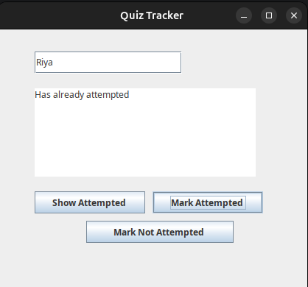

Application Scenario - STUDENT TASK

Code:
Superhero.java :
public class Superhero {
String name;
boolean onMission;
Superhero(String n) {
name = n;
onMission = false;
}
void sendOnMission() {
onMission = true;
}
void recallToBase() {
onMission = false;
}
boolean isOnMission() {
return onMission;
}
String getName() {
return name;
}
}

MissionControl.java :
import java.util.*;
public class MissionControl {
ArrayList<Superhero> heroes = new ArrayList<>();
void addHero(Superhero h) {
heroes.add(h);
}
String sendHero(String name) {
for (Superhero h : heroes) {
if (h.getName().equalsIgnoreCase(name)) {
if (h.isOnMission()) {
return name + " is already on a mission!";
}
h.sendOnMission();
return name + " has been sent on a mission.";
}
}
return "Superhero '" + name + "' not found!";
}
String recallHero(String name) {
for (Superhero h : heroes) {
if (h.getName().equalsIgnoreCase(name)) {
if (!h.isOnMission()) {
return name + " is already at the base!";
}
h.recallToBase();
return name + " has been recalled to base.";
}
}
return "Superhero '" + name + "' not found!";
}
String showActiveMissions() {
String result = "";
for (Superhero h : heroes) {
if (h.isOnMission()) {
result += h.getName() + "\n";
}
}
if (result.equals("")) {
return "No superheroes are currently on a mission.";
}
return "Heroes on Active Missions:\n" + result;
}
}

UImain.java :
import javax.swing.*;
public class UImain {
public UImain(MissionControl sys) {
JFrame frame = new JFrame("Superhero Mission Control");
frame.setLayout(null);
// Label for input
JLabel inputLabel = new JLabel("Enter Superhero Name:");
inputLabel.setBounds(50, 20, 200, 25);
// Input field
JTextField input = new JTextField();
input.setBounds(50, 50, 200, 30);
// Output area
JTextArea output = new JTextArea();
output.setBounds(50, 100, 300, 120);
output.setEditable(false);
output.setLineWrap(true);
// Buttons
JButton showBtn = new JButton("Show Active Missions");
JButton sendBtn = new JButton("Send on Mission");
JButton recallBtn = new JButton("Recall to Base");
showBtn.setBounds(50, 240, 180, 30);
sendBtn.setBounds(50, 280, 180, 30);
recallBtn.setBounds(50, 320, 180, 30);
// Button Actions
showBtn.addActionListener(e ->
output.setText(sys.showActiveMissions())
);
sendBtn.addActionListener(e ->
output.setText(sys.sendHero(input.getText().trim()))
);
recallBtn.addActionListener(e ->
output.setText(sys.recallHero(input.getText().trim()))
);
// Add all components
frame.add(inputLabel);
frame.add(input);
frame.add(output);
frame.add(showBtn);
frame.add(sendBtn);
frame.add(recallBtn);
frame.setSize(420, 400);
frame.setVisible(true);
frame.setDefaultCloseOperation(JFrame.EXIT_ON_CLOSE);
}
}

MainAppFile.java :
import javax.swing.*;
public class MainAppFile {
public static void main(String[] args) {
MissionControl sys = new MissionControl();
sys.addHero(new Superhero("Batman"));
sys.addHero(new Superhero("Spiderman"));
sys.addHero(new Superhero("WonderWoman"));
// Build GUI and connect system
SwingUtilities.invokeLater(() -> new UImain(sys));
}
}

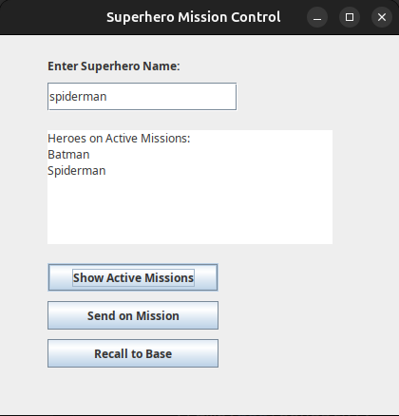
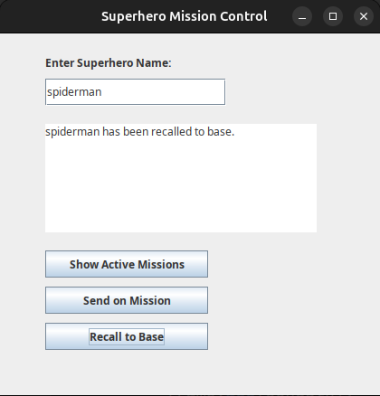
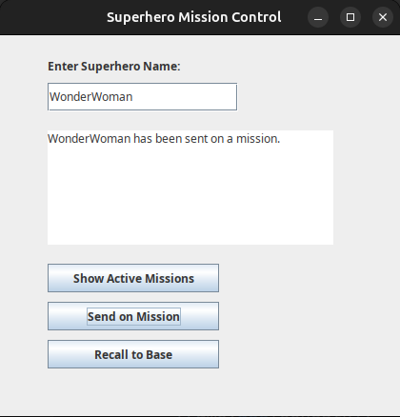
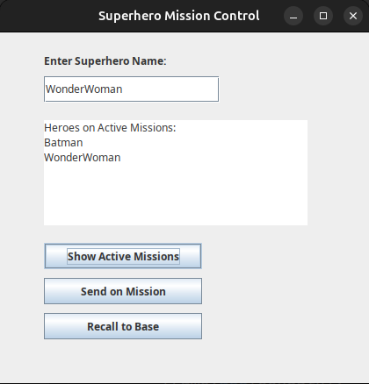
Output:

